CLOUD COMPUTING
LAB 05



Submitted To:
Engr. Shoaib

Submitted By:
Komal Kashif
BSE V-A
2023-BSE-031

Task 1 - Discover missing command & install Java using apt suggestion
Steps
- Run the java command to see what the system suggests:
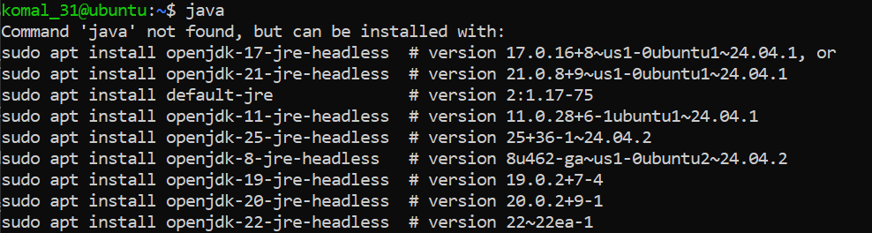
- Use the suggested apt command (copy the exact package name suggested by the system). sudo apt install <suggested-package> -y
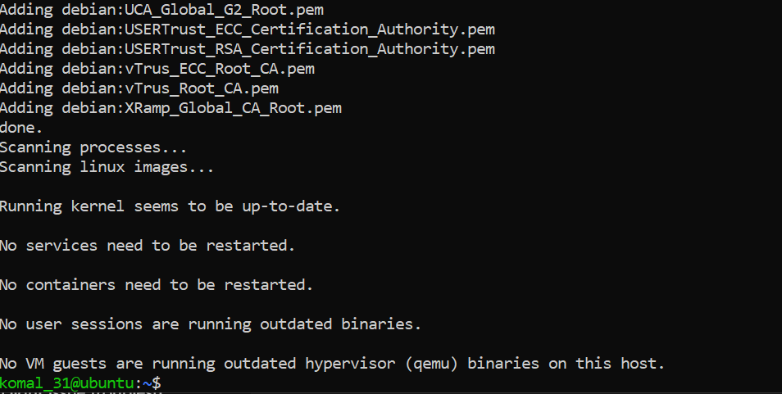

- Verify Java is installed and check version:
java –version
- Remove the Java package using apt remove (use the same package name you installed):
sudo apt remove <suggested-package> -y
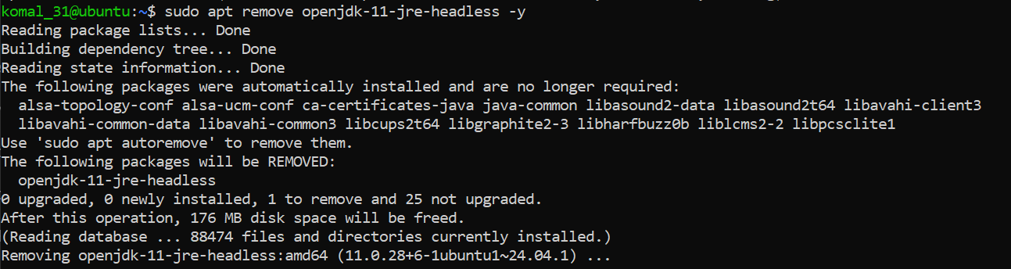

- Confirm java is no longer available (run java again) — it should again indicate "not found" or suggest installation:
java
- Clear the shell's command hash cache so the shell forgets cached command locations (run as your regular user — no sudo required):
hash -r
java
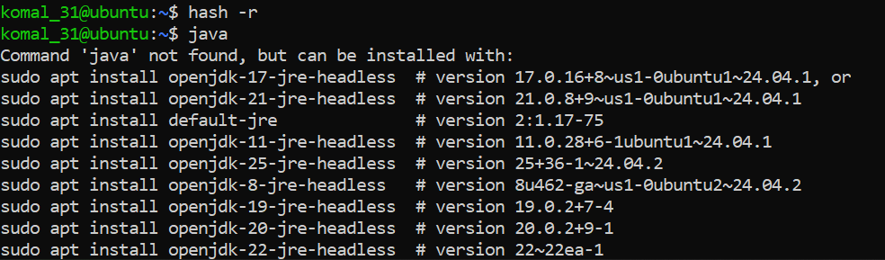

Task 2 - Install & remove Java using apt-get (explicitly)
Steps
- Install Java using apt-get (choose a common package, e.g., default-jre — or the same package you used in Task 1):
sudo apt-get update
sudo apt-get install default-jre -y
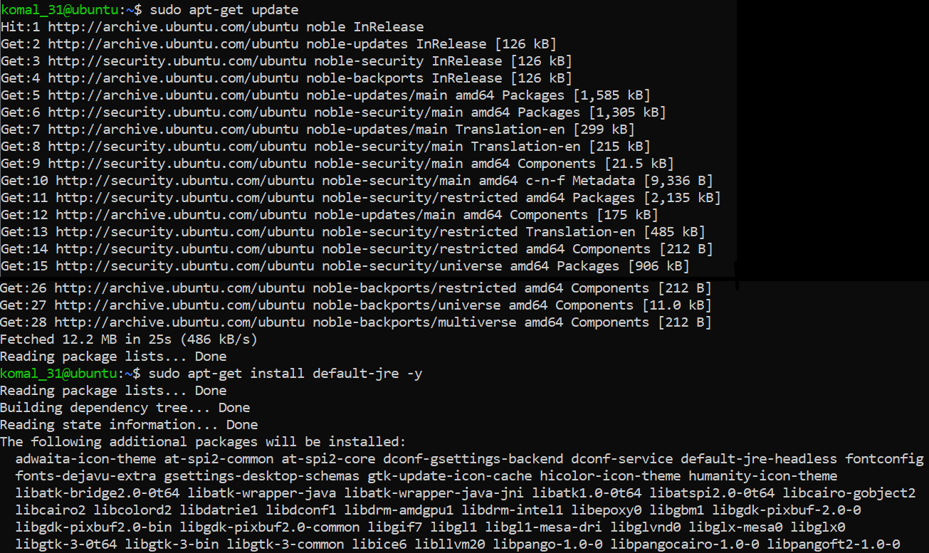
- Verify Java version again:
java –version
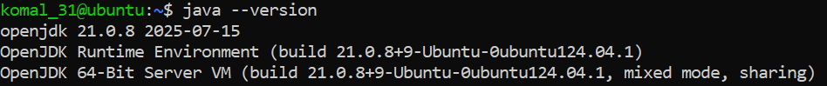
- Remove Java using apt-get remove:
sudo apt-get remove default-jre -y
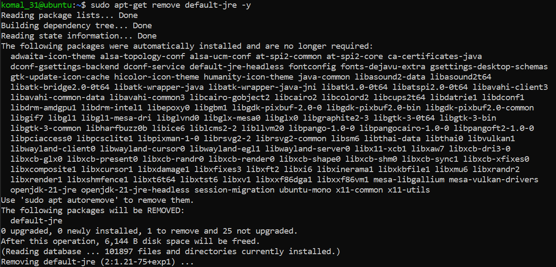
- Clear the terminal hash cache and confirm java is missing:
hash -r
java
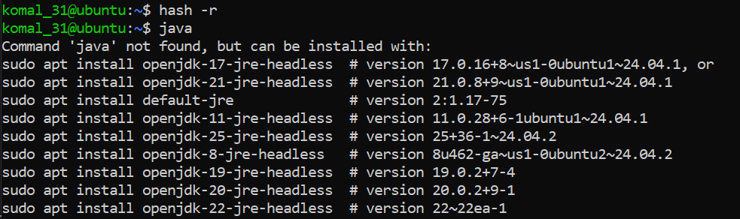

Task 3 - apt update vs apt upgrade - run & explain
Steps
- Update the package index (this downloads the latest lists of available packages):
sudo apt update
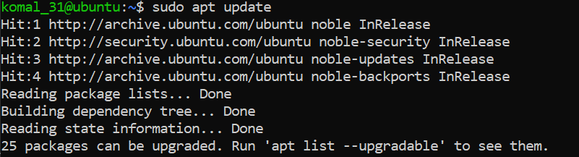
- Upgrade installed packages (this installs available updates for currently installed packages):
sudo apt upgrade
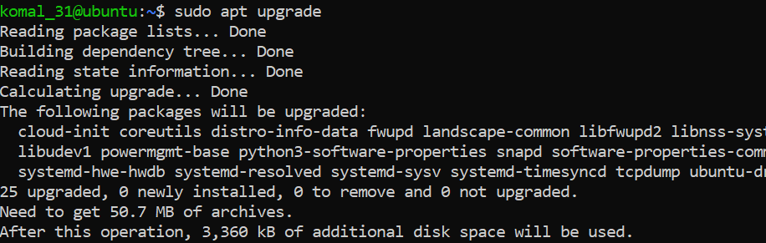
- Write a short 3–5 sentence explanation describing the difference between apt update and apt upgrade. Put your text into a small file and capture it as a screenshot (do not upload the text file; provide the screenshot):
nano ~/apt_update_vs_upgrade.md
# write 3-5 sentences, save and exit
Open the file or show it on screen
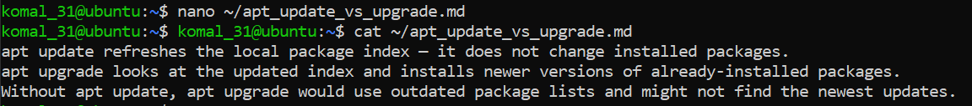

Task 4 - Install Visual Studio Code via snap on CLI and verify (DO NOT remove Code)
Steps
- Install VS Code via snap (snap may require sudo):
sudo snap install --classic code
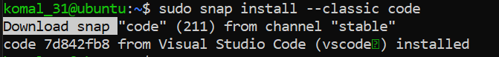
- Verify snap shows the package is installed:
snap list code
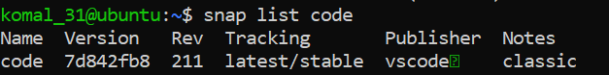
- Check the installed application's version. On some systems code --version is available; also check snap info:
code –version
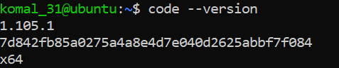
- If the code binary is not in PATH, show where the snap placed it:
ls -l /snap/bin | grep code

Task 5 - Install XFCE GUI + XRDP - minimal desktop and remote access (GUI) and launch VS Code
Steps
- From your host, open your preferred terminal (for example: Windows Command Prompt, PowerShell, macOS Terminal, or Linux Terminal) and connect to the VM using SSH. Example:
ssh student@<vm-ip-address>
- Update the server (download package lists and apply upgrades):
sudo apt update && sudo apt upgrade -y
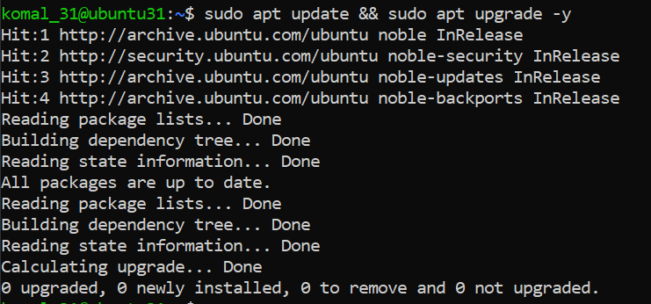
- Install XFCE and XFCE goodies (lightweight desktop):
sudo apt install xfce4 xfce4-goodies -y
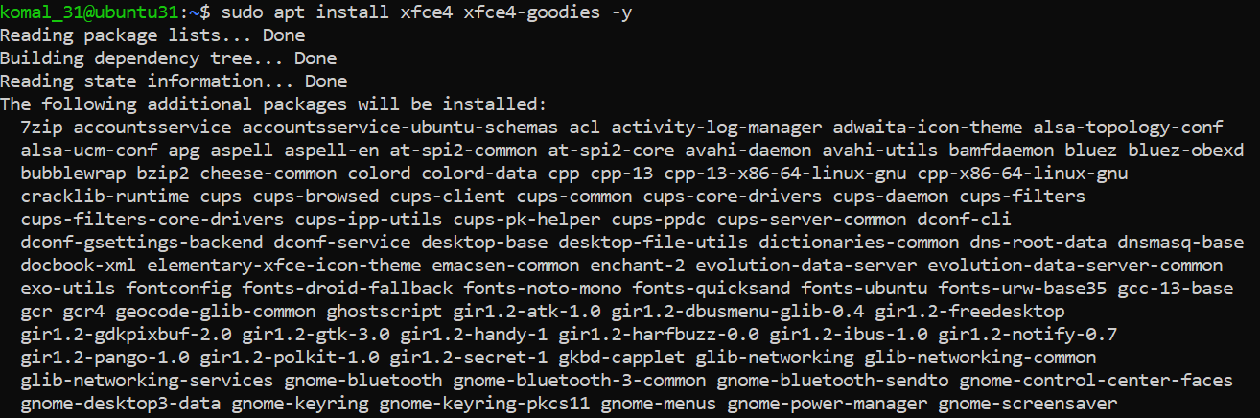

- Install and enable XRDP (Remote Desktop Protocol server):
sudo apt install xrdp -y
sudo systemctl enable --now xrdp
- Verify XRDP status:
sudo systemctl status xrdp
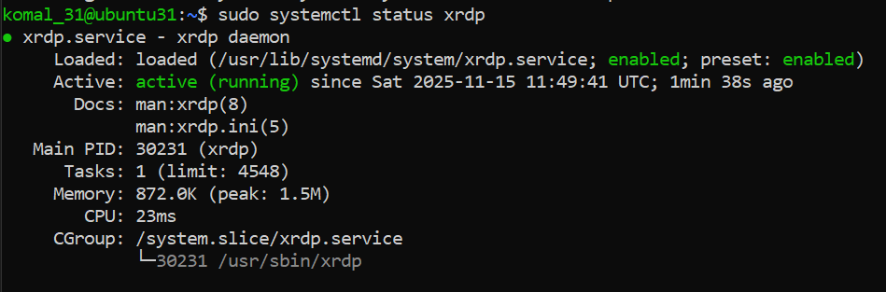
- Configure XRDP to use XFCE session:
echo xfce4-session > ~/.xsession
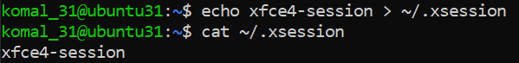
- Save screenshot as: task5_xsession.png
- After you are in the GUI (local console or RDP session), launch Visual Studio Code (installed in Task 4) from the GUI menu or a terminal inside the GUI. Example command from a GUI terminal:
code
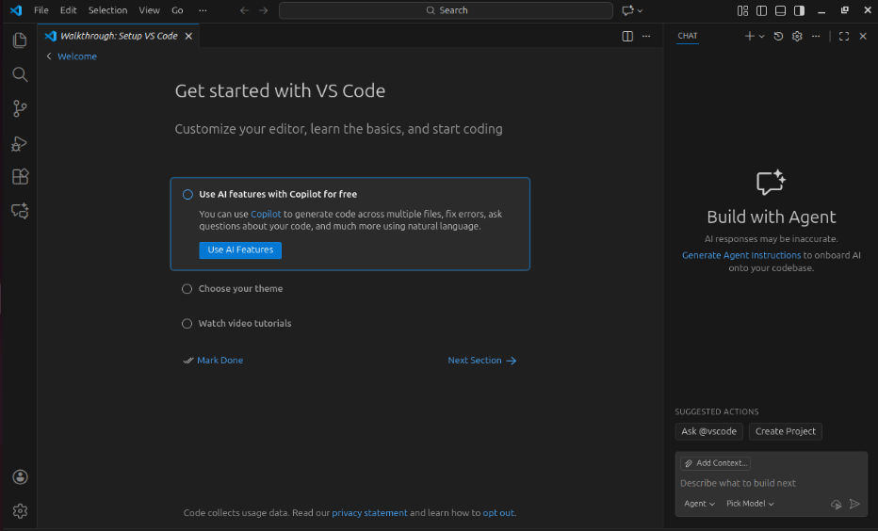
Task 6 - Install lightdm-gtk-greeter and GUI verification - start GUI, open VS Code, take snapshot, then end (GUI)
Steps (inside the host terminal / via SSH)
- Fix GUI login screen issues (if lightdm / greeter problems appear)
- Install LightDM and greeter using Host Terminal:
sudo apt install lightdm lightdm-gtk-greeter -y
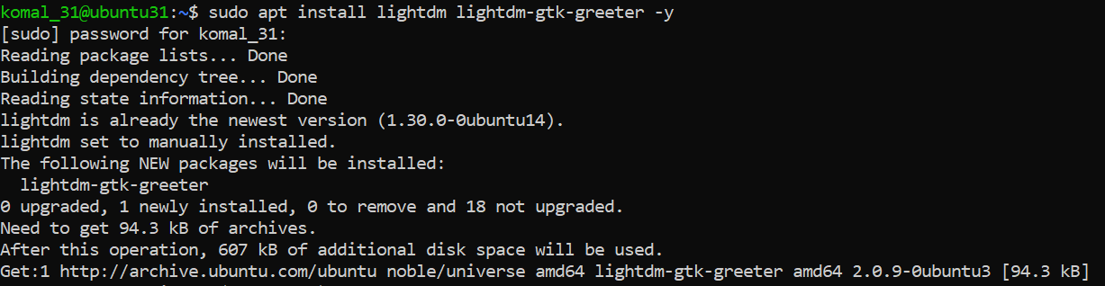
- Create LightDM config to use XFCE:
sudo mkdir -p /etc/lightdm/lightdm.conf.d
echo -e "[Seat:*]\ngreeter-session=lightdm-gtk-greeter\nuser-session=xfce\nautologin-user-timeout=0" | sudo tee /etc/lightdm/lightdm.conf.d/99-xfce.conf
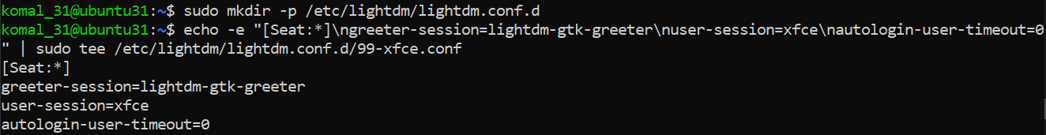
- Clean up problematic session files and permissions:
sudo rm -f /var/lib/lightdm/.Xauthority
sudo rm -f ~/.Xauthority
sudo rm -rf ~/.cache/sessions
sudo chown -R $USER:$USER /home/$USER
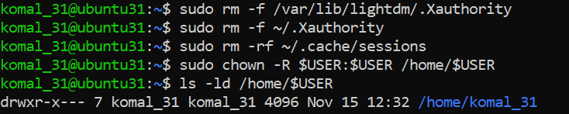
- Restart LightDM:
sudo systemctl restart lightdm
- Control GUI login at boot — ENABLE first, then DISABLE (observe and understand terminal/GUI behavior after each reboot)Enable GUI Login Screen (Boot to GUI)
  - Re-enable LightDM and set the graphical target as default:
sudo systemctl enable lightdm
sudo systemctl set-default graphical.target
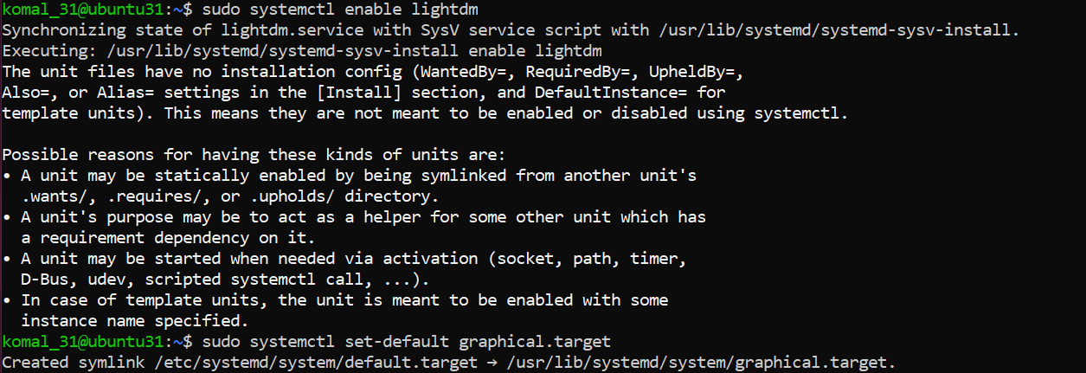
- Reboot the VM to observe that it boots to the GUI login screen:
sudo reboot
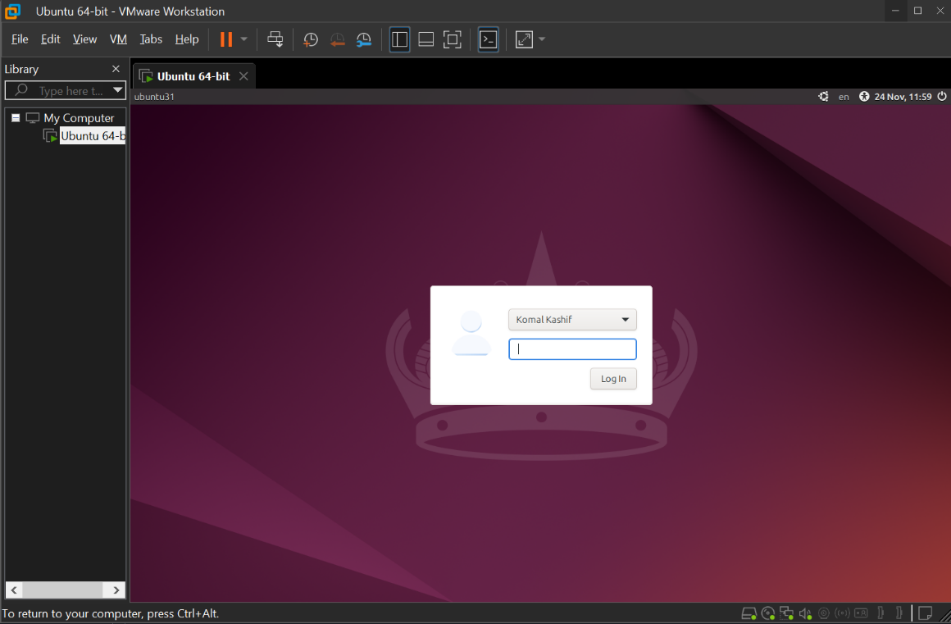
- Disable GUI Login Screen (Boot to CLI)
  - Set the default boot target to multi-user (text mode) and disable LightDM so the system boots to the terminal:
sudo systemctl set-default multi-user.target
sudo systemctl disable lightdm
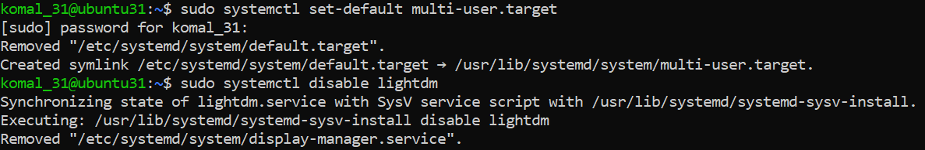
- Reboot the VM to observe that it boots to the terminal (CLI):
sudo reboot
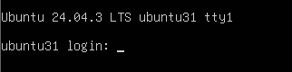
- Start/Stop GUI manually (no reboot)
sudo systemctl start lightdm
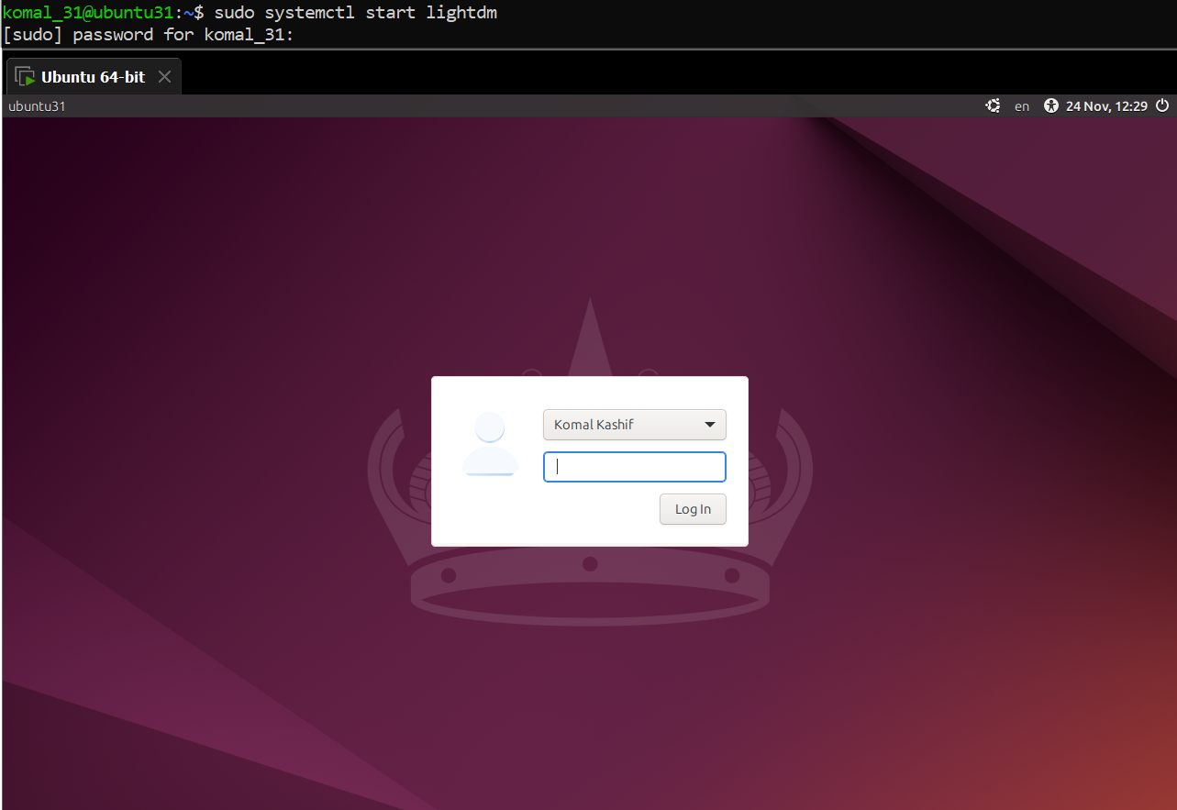
sudo systemctl start lightdm
- Press Ctrl + Alt + F3 to switch back to TTY. You can stop the GUI session without changing the boot target.
sudo systemctl stop lightdm
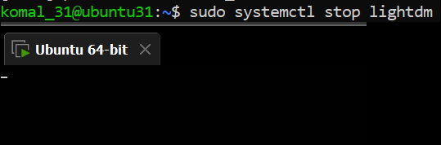
- Start the GUI (if the system is currently set to CLI or the GUI is not running):
sudo systemctl start lightdm
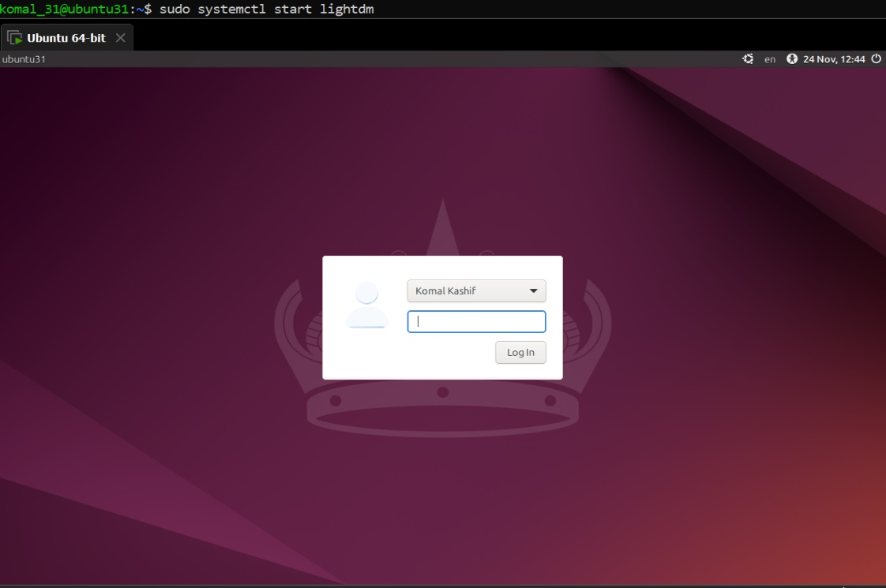
- In the GUI session launch Visual Studio Code (installed earlier in Task 4). From a GUI terminal inside the desktop, run:
Code
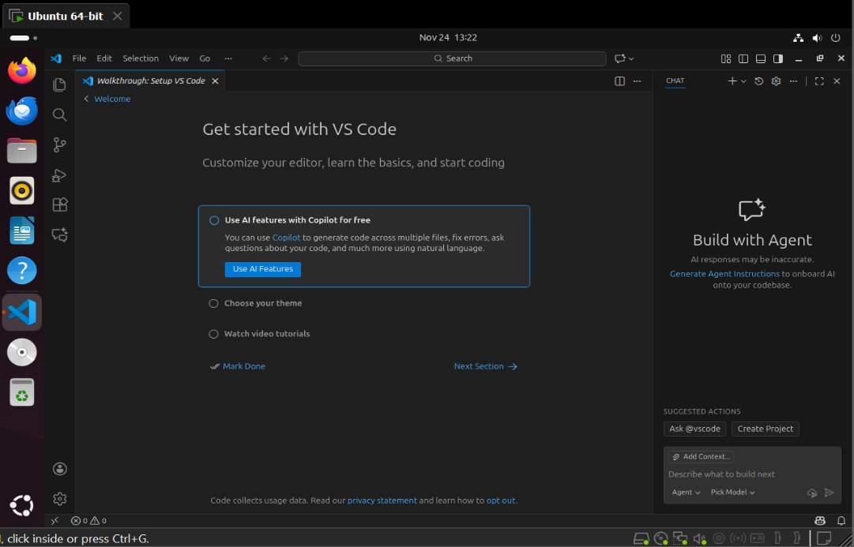
Task 7 - Install Google Chrome by adding its apt source & key (Chrome)
Steps (inside the VM terminal or GUI terminal or host terminal / via SSH)
- (Learning step — first command must be the install attempt) Attempt to install Google Chrome directly to see the failure when the repo/key are missing:
sudo apt install google-chrome-stable -y
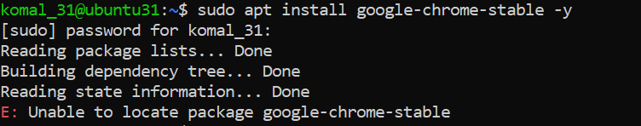
- Inspect apt configuration so you understand why install failed. List the /etc/apt directory:
ls -la /etc/apt
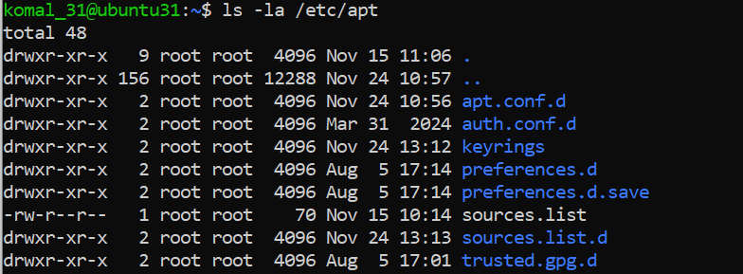
- View the main /etc/apt/sources.list:
cat /etc/apt/sources.list
- List files under /etc/apt/sources.list.d:
ls -la /etc/apt/sources.list.d/
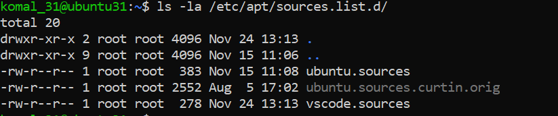
- If there is a file named ubuntu.sources (or similarly named source file), display it to see whether Chrome's repo is present:
cat /etc/apt/sources.list.d/ubuntu.sources
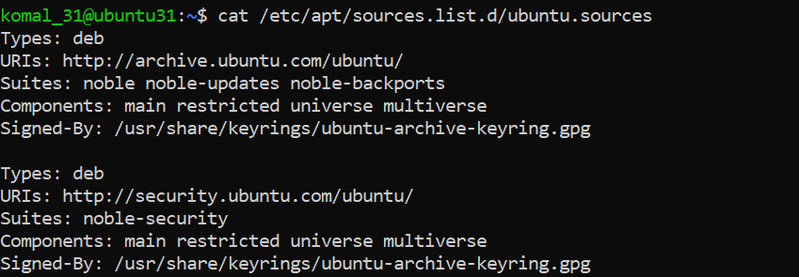
- Add Chrome repository metadata to a sources file (method A — using ubuntu.sources). Open or create the file and append the stanza (you can alternatively use the preferred one-line method in step 11):
sudo nano /etc/apt/sources.list.d/ubuntu.sources
- Append these exact lines at the end of the file:
Types: deb
URIs: http://dl.google.com/linux/chrome/deb/
Suites: stable
Components: main
Architectures: amd64
Signed-By: /etc/apt/keyrings/google.gpg
- Save the file (Ctrl+O → Enter) and exit (Ctrl+X).
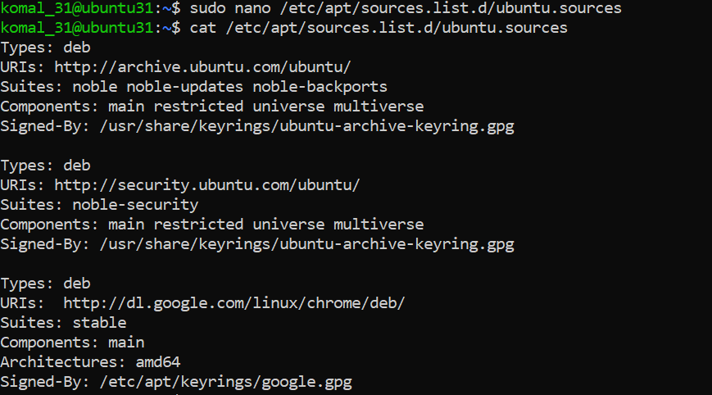
- Ensure the keyrings directory exists and import Google's signing key:
curl -fsSL https://dl.google.com/linux/linux_signing_key.pub | sudo gpg --dearmor -o /etc/apt/keyrings/google.gpg

- Update apt and attempt to install Chrome again (now that repo + key are added):
sudo apt update
sudo apt install google-chrome-stable -y
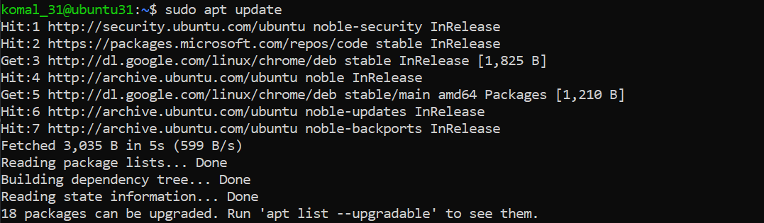
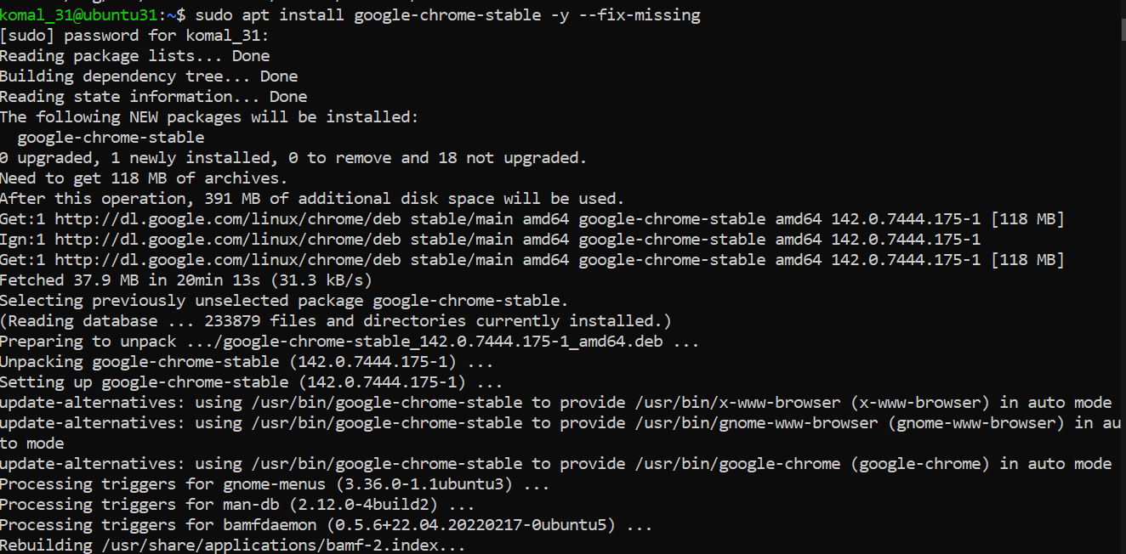
Alternate method — create a single google-chrome.list entry
- Cleanup before alternate method you added the chrome earlier and want to switch to the preferred method:
sudo apt remove google-chrome-stable -y
sudo nano /etc/apt/sources.list.d/ubuntu.sources # remove the chrome stanza you added earlier, save and exit
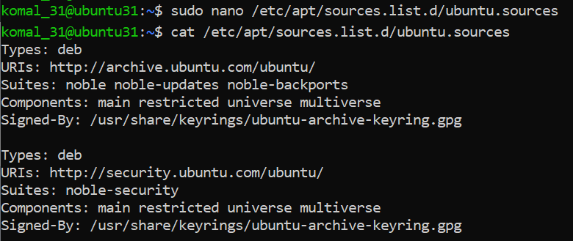
sudo rm -f /etc/apt/keyrings/google.gpg
- Create a dedicated one-line list file for Google Chrome (preferred):
echo "deb [arch=amd64 signed-by=/etc/apt/keyrings/google.gpg] http://dl.google.com/linux/chrome/deb/ stable main" | sudo tee /etc/apt/sources.list.d/google-chrome.list > /dev/null
- Verify the new file exists:
ls -la /etc/apt/sources.list.d/
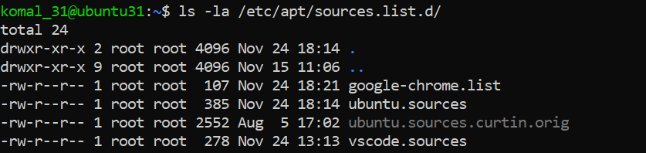
- Re-add the Google signing key (if removed previously or not present):
sudo mkdir -p /etc/apt/keyrings
curl -fsSL https://dl.google.com/linux/linux_signing_key.pub | sudo gpg --dearmor -o /etc/apt/keyrings/google.gpg
- Update apt and install Chrome (preferred flow):
sudo apt update
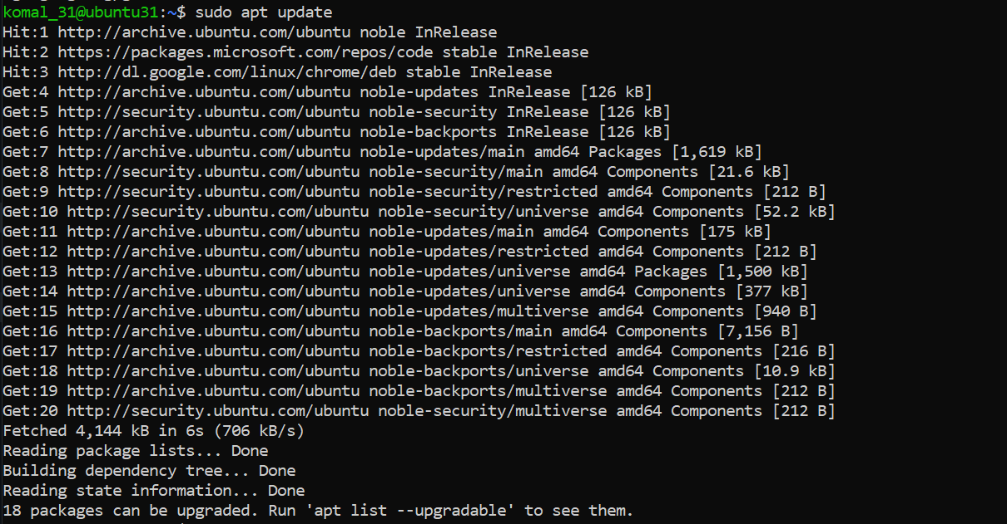
sudo apt install google-chrome-stable -y
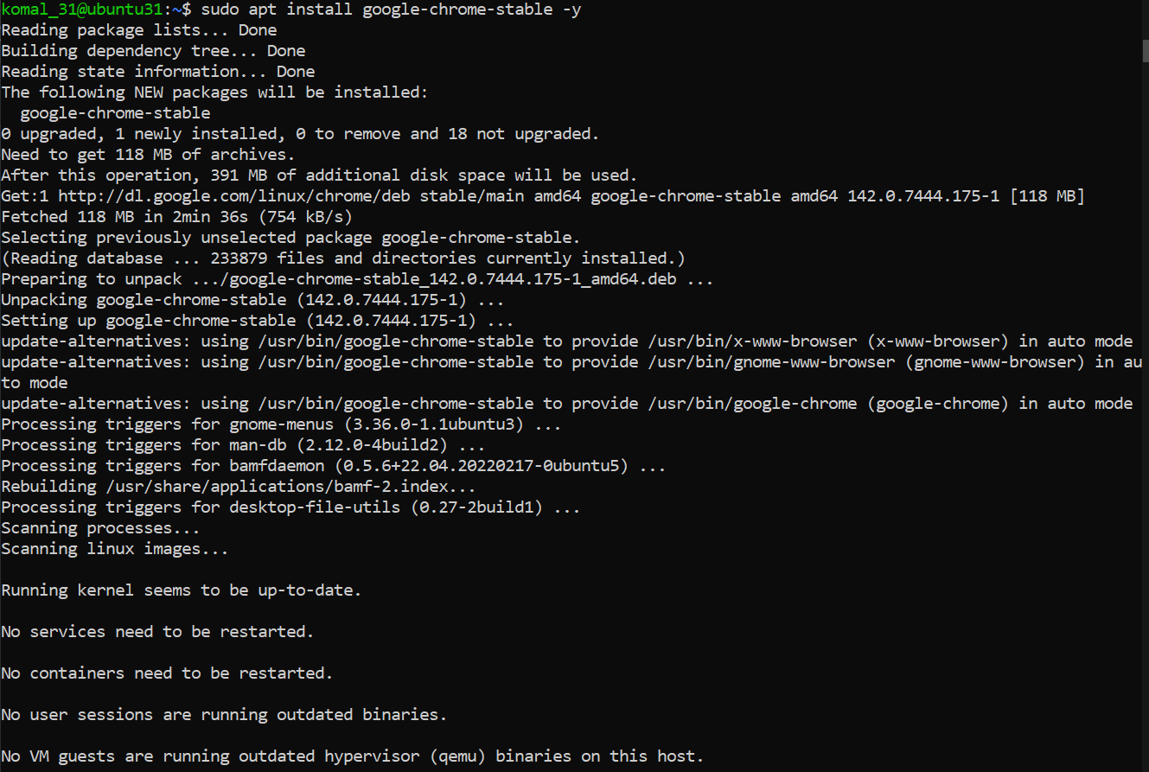

Task 8 - Install applications via PPA (Audacity & OBS) and launch
Steps (inside the VM terminal or GUI terminal)
- Add the Audacity PPA, update apt and install audacity:
sudo add-apt-repository ppa:ubuntuhandbook1/audacity -y
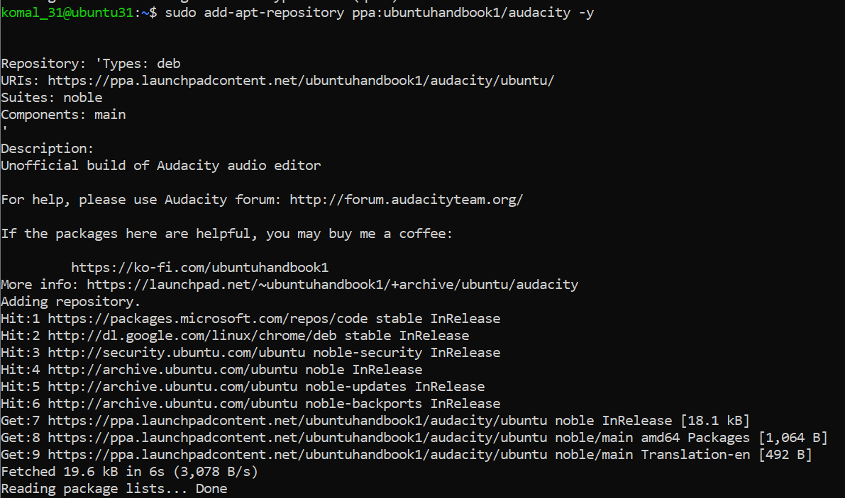
sudo apt update
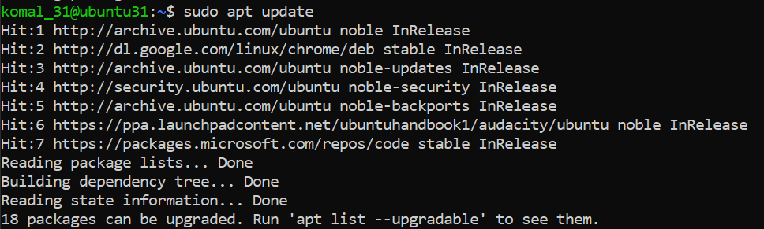
sudo apt install audacity -y
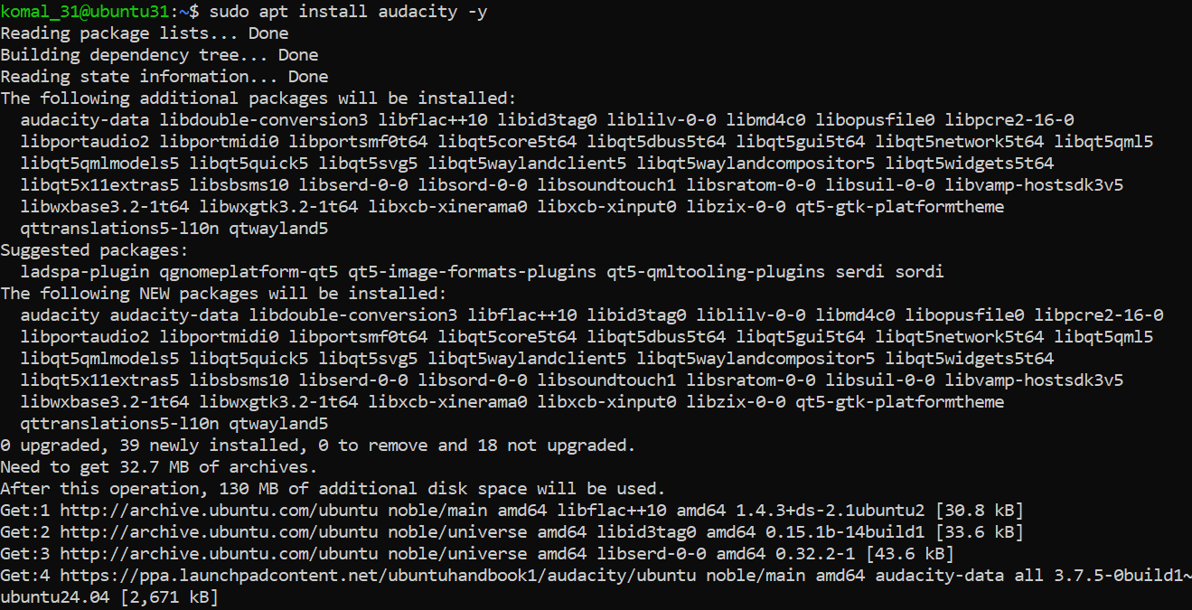
- Launch Audacity (from GUI or CLI). On a headless server you may not get a GUI window — if you are using the XFCE GUI session, launch from a GUI terminal or run check for binary:
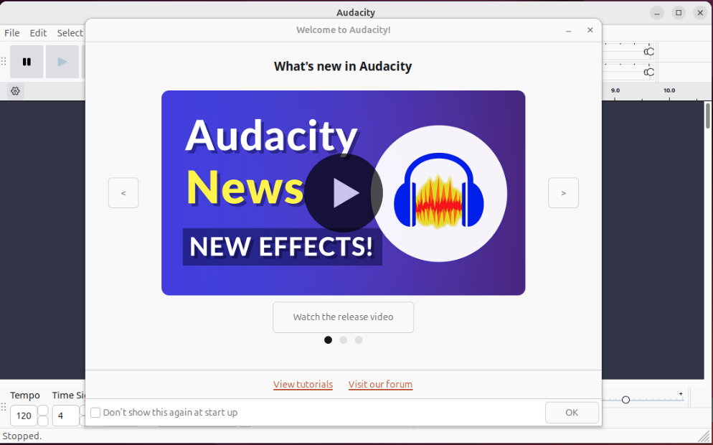
- Add the OBS Studio PPA, update apt and install obs-studio:
sudo add-apt-repository ppa:obsproject/obs-studio -y
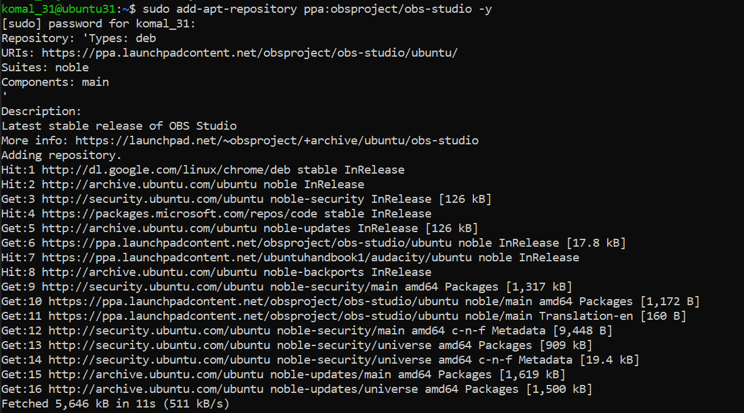
sudo apt update
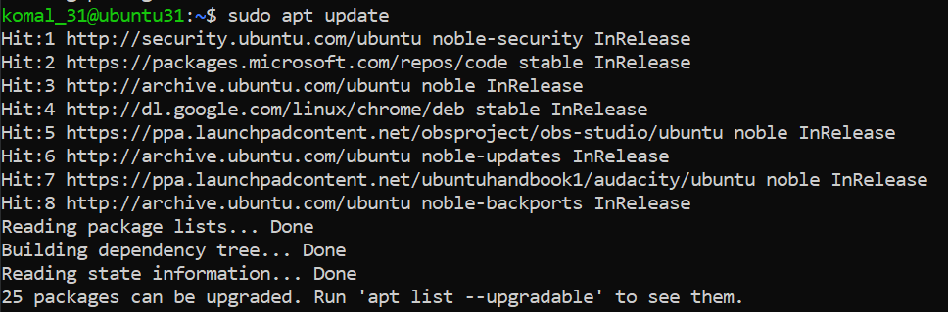
sudo apt install obs-studio -y
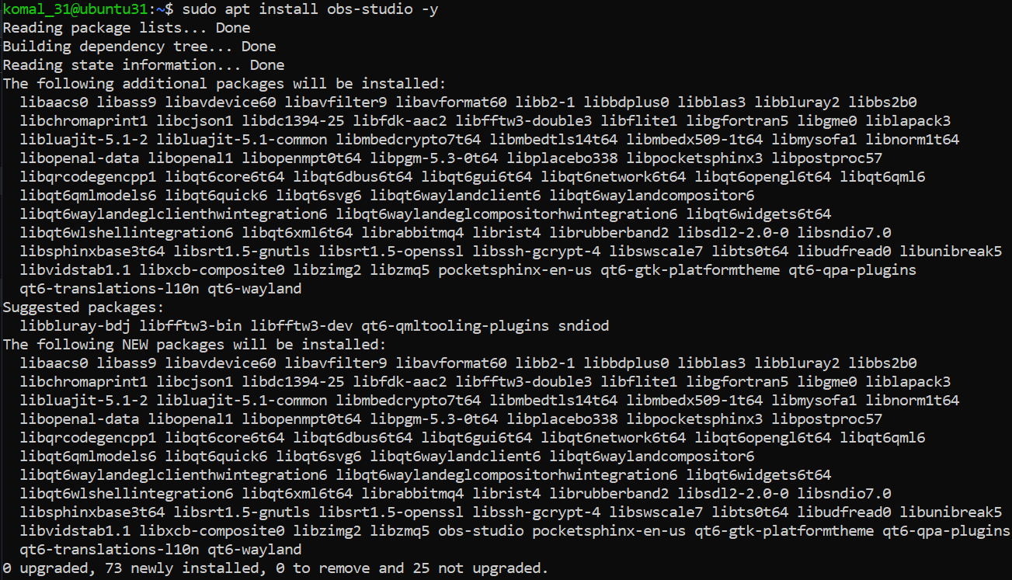
- Launch OBS Studio (from GUI or verify binary presence):
obs --version
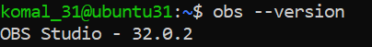

Task 9 - Create a Kubernetes sample YAML using vim
Steps (inside the VM terminal or host terminal / via SSH)
- Check whether vim is installed by running:
vim
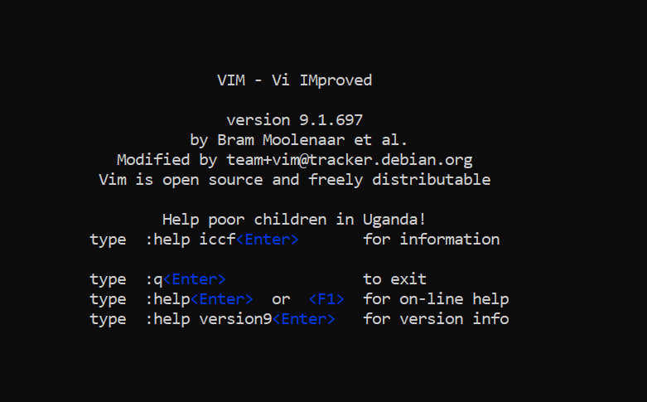
Vim is already installed.
- Create the Lab5 working directory in your home and change into it:
mkdir -p ~/Lab5
cd ~/Lab5
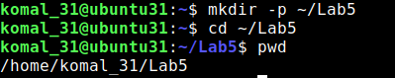
- Create the Kubernetes sample file using vim:
vim k8s-sample.yaml
- Once vim opens, enable insert mode by pressing i, then paste the following YAML exactly:
apiVersion: v1
kind: Pod
metadata:
name: nginx-pod
spec:
containers:
- name: nginx
image: nginx:1.19
ports:
- containerPort: 80
restartPolicy: Always

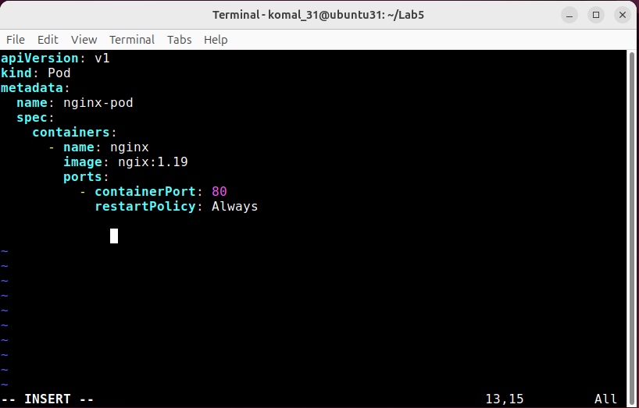
- Exit insert mode by pressing Esc, then save and quit vim with:
:wq
- Save a screenshot of the ls -la output showing the file exists
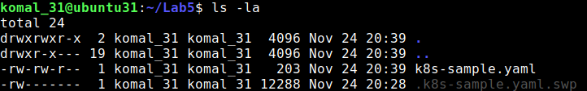

Task 10 - Edit the Kubernetes YAML - add annotation, verify, then discard temporary change.
Steps (inside the VM terminal or host terminal / via SSH)
- Open the manifest with vim:
cd ~/Lab5
vim k8s-sample.yaml
- When vim opens, ensure you are in command mode (press Esc) then press i to enter insert mode.
- Add the annotation under the metadata section (indentation must match YAML). Example (insert these lines under metadata:):
annotations:
lab: lesson11
- After adding the lines, press Esc to return to command mode and save & quit:
:wq
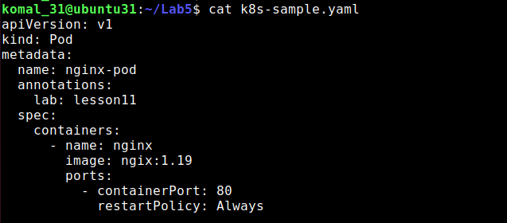
- Discard changes (practice: make a temporary edit and exit without saving)
- Open the file again:
vim k8s-sample.yaml
- Enter insert mode (i) and add a temporary comment line anywhere, for example:
# temp: do-not-keep
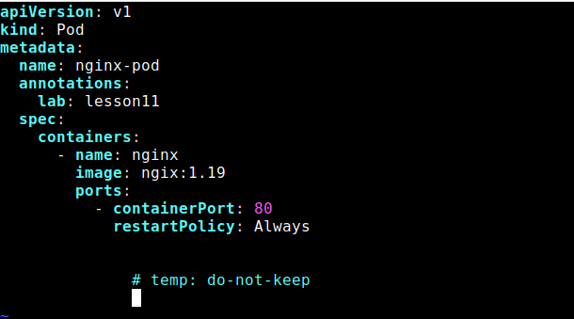
- Do NOT save. Press Esc to go back to command mode, then force quit without savin
- Verify the file does NOT contain the temporary comment
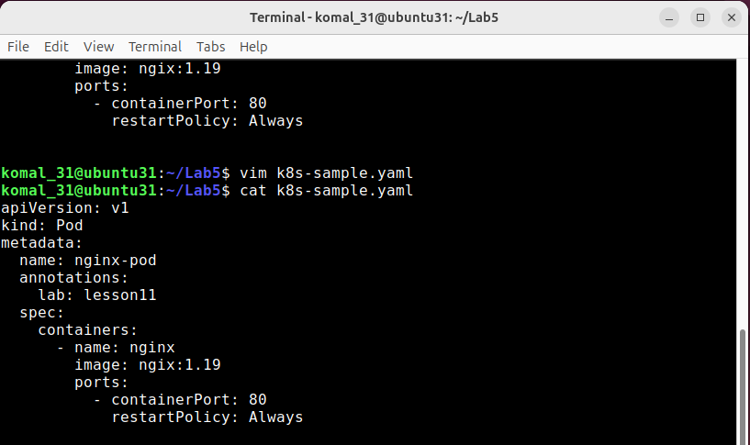
Task 11 - Vim editing practice - delete, undo, numeric deletes, navigation
Steps (inside the VM terminal or host terminal / via SSH)
- Open the file with vim:
cd ~/Lab5
vim k8s-sample.yaml
- Delete the line containing image: nginx:1.19 with a single command:
- Ensure you are in command mode (press Esc), move the cursor to the line with image: nginx:1.19, then delete that line
- Immediately undo the deletion with:
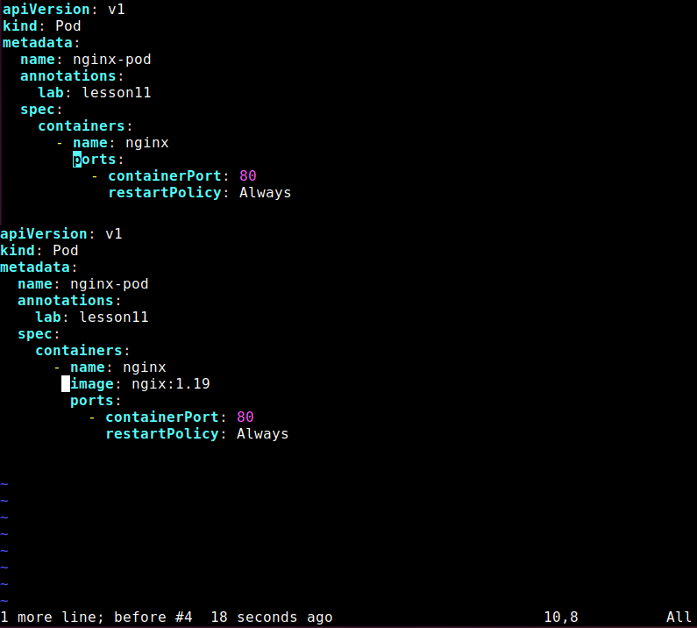
- Delete 3 lines at once using the numeric delete command:
- In command mode, position the cursor on the first line of the three you want to delete (for example start at the image: line again), then run:
d3d
(or 3dd or d3<enter> — either numeric prefix form is acceptable; document which you used)
- Immediately undo the deletion with:
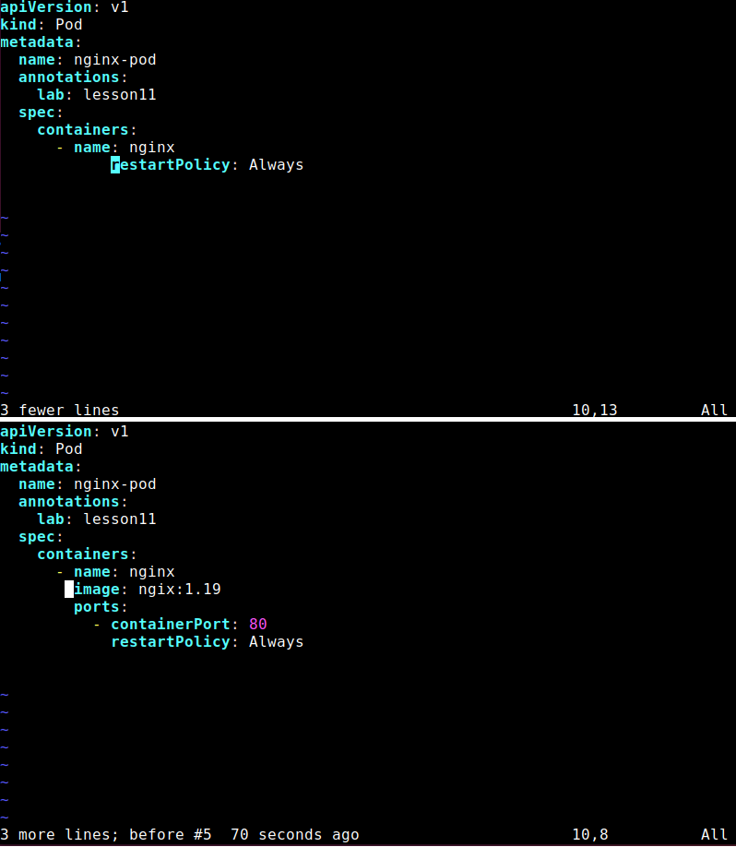
- Navigation practice (from command mode)
- Jump to the first line:
1G
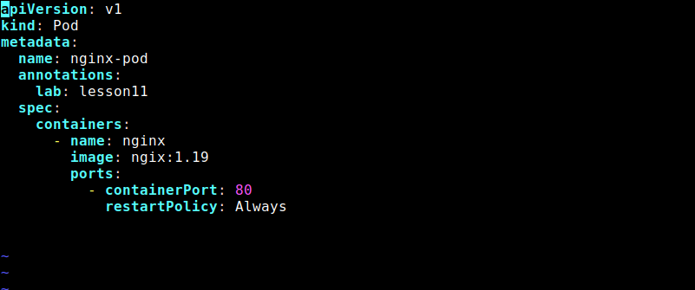
- Jump to the last line:
G
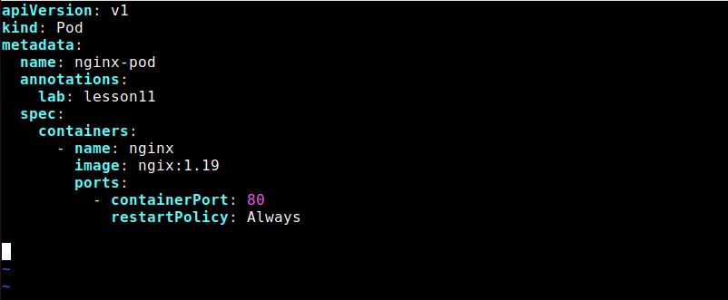
Task 12 - Vim search, add matches, substitute, undo
Steps (inside the VM terminal / in the ~/Lab5 directory)
- Open the file with vim:
cd ~/Lab5
vim k8s-sample.yaml
- Search for the string nginx using the forward search command:
- From command mode type:
/nginx
and press Enter.
- Note the first match is highlighted and the cursor is placed on it.
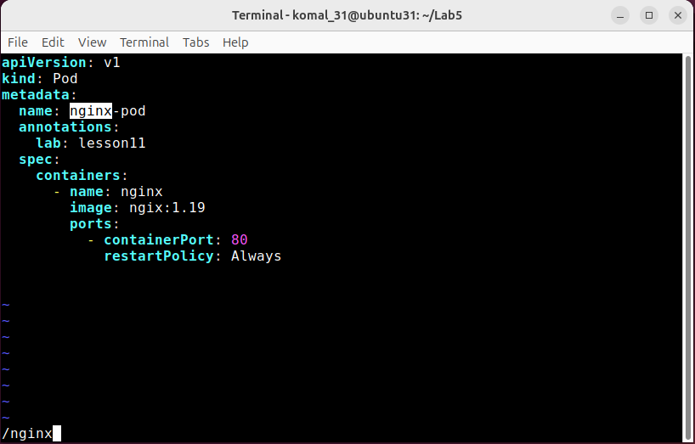

- Move to the next match and previous match:
- Press n to jump to the next match (capture screenshot if desired) and press N to jump back to the previous match.
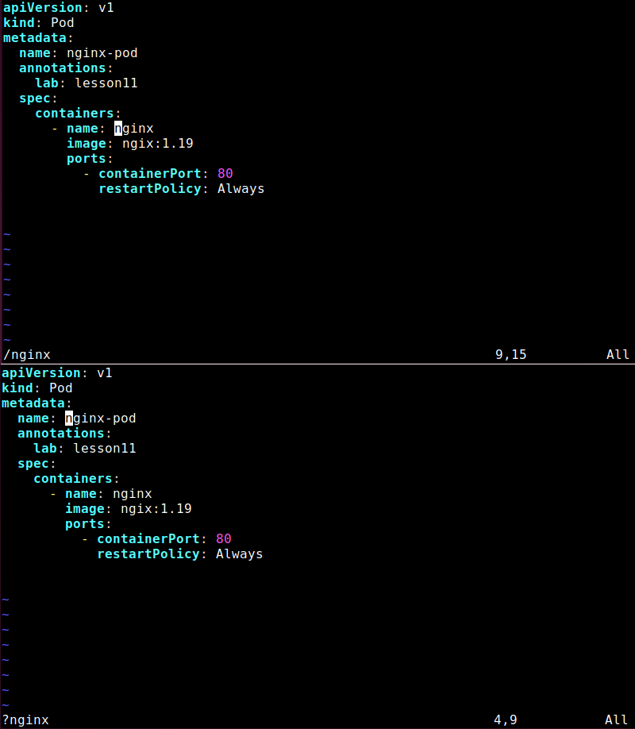
- Add two more occurrences of the word nginx in the file:
- Enter insert mode (i) at an appropriate place (for example add two new comment lines or add them under metadata as comments), type two new occurrences of nginx, then press Esc to return to command mode and save the file with :w.
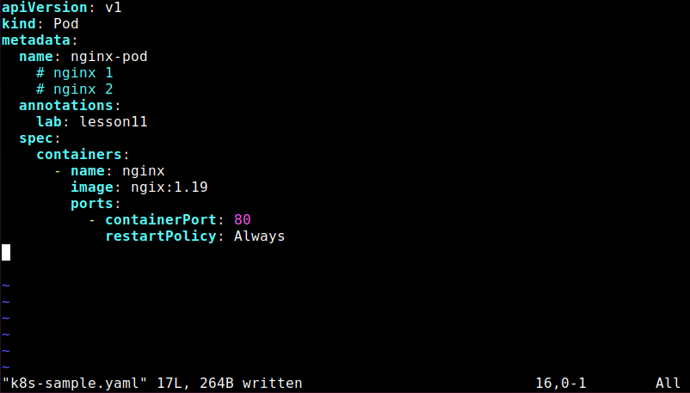
- Demonstrate that n cycles forward through all matches:
- In vim command mode press /nginx Enter, then repeatedly press n to cycle forward through each match.
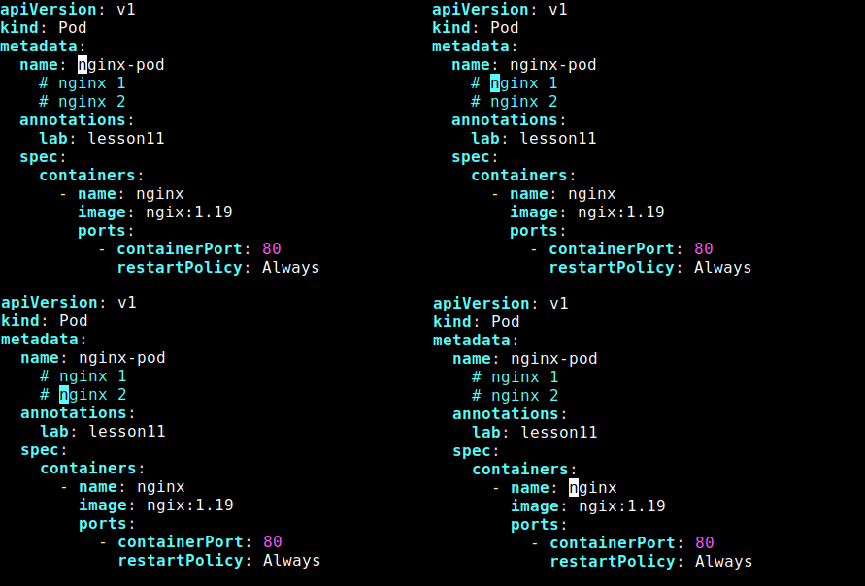
- Substitute all occurrences of nginx with webapp:
- From command mode execute the substitute command:
:%s/nginx/webapp
- This will replace all occurrences in the file (note: this changes the buffer).
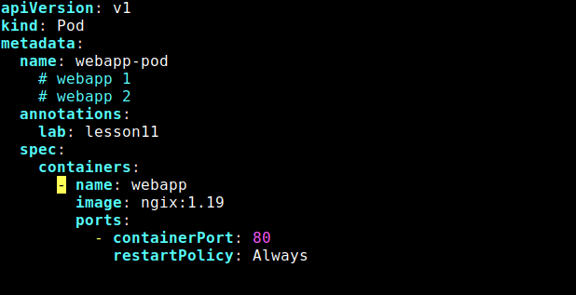

- Immediately undo the substitution using u:
- Press u in command mode to undo the last change.
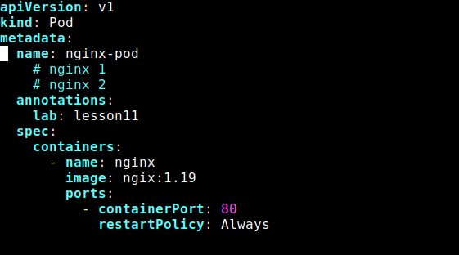

Exam Evaluation Question
- Install Docker Desktop on your VMWare Workstation Ubuntu Server. No commands or solutions are provided in this lab — treat this as an evaluation/exam question.
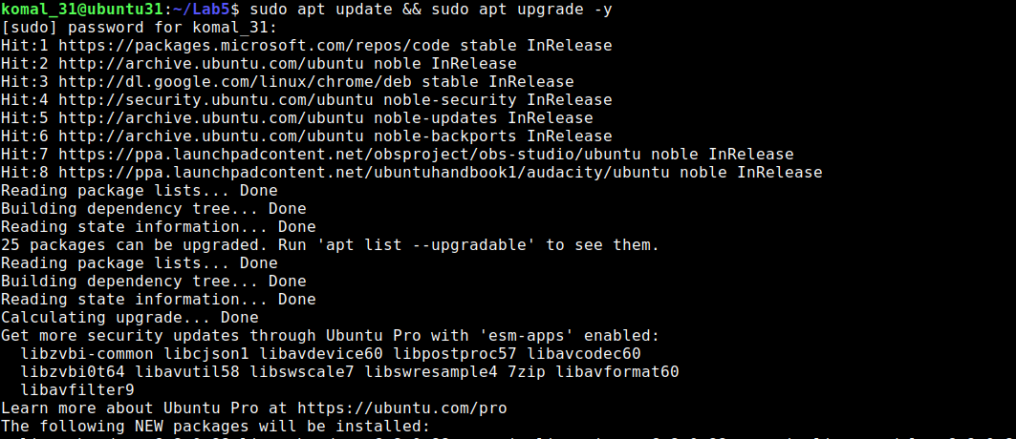
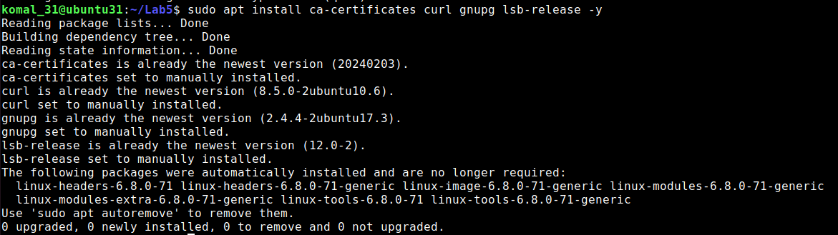
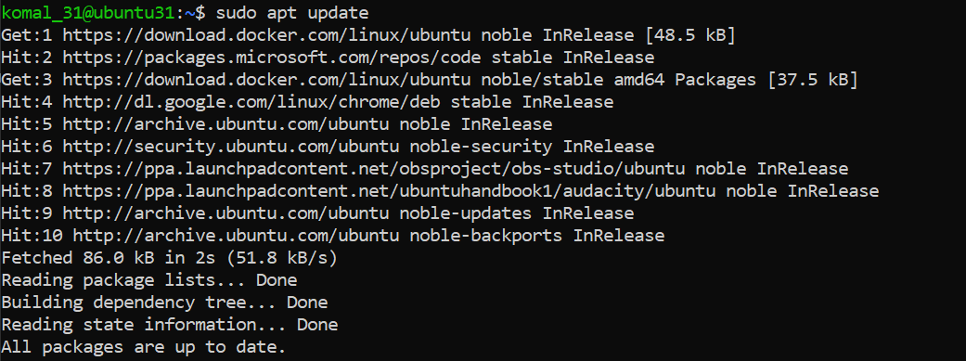
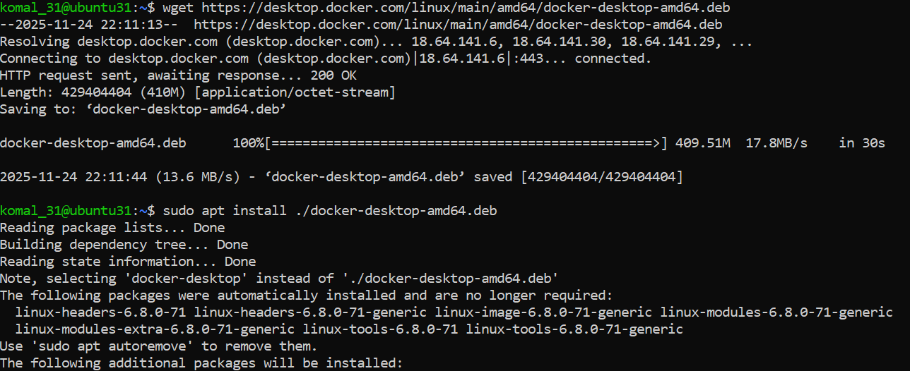
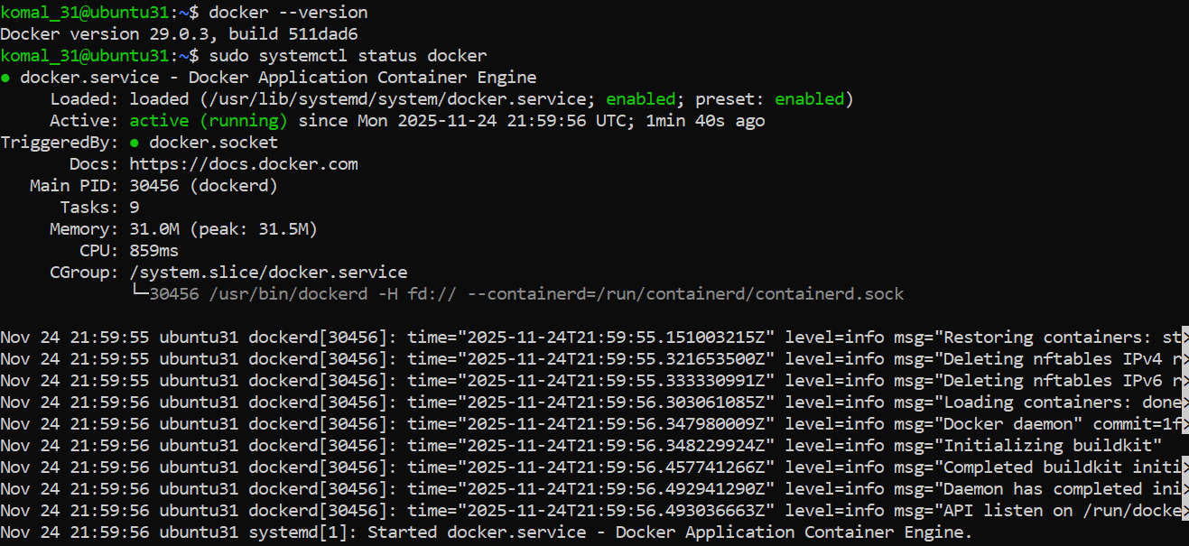
- Verify Docker Desktop is installed by launching the Docker Desktop application and confirming it runs.
